Group Therapy For Internet Addicts
My Name
Course Name
Lamar University
Semester Year Term

Group Counseling Proposal for Internet Addicts
Group counseling purpose differs from one group to another. However, most groups' purpose base on either of the following topics namely education, therapy, or helping individuals to achieve vital life transformations in their behavior, feelings or mode of thinking (Corey, 2015). When contrasted to personal therapy based on effectiveness scale, group counseling is by far more successful reason being it closely kindles social relations and interactive forms of communication as opposed to a personal group. Evaluating internet use will help in achieving the project objectives through weekly counseling sessions that promote profound intuition and self-awareness, and helping members wage positive efforts towards overcoming and eliminating self-defeating behaviors on internet use. Therefore, the paper will aim at formulating a group counseling proposal to help adolescents of internet addiction by mainly focusing on various sections namely background, group logistics, group leadership as well as theory together with techniques and finally creating a flyer.
Background
The potential problem that I would like my group to tackle is internet addiction, explicitly the problem of high school as well as university adolescents suffering from internet addiction. According to Young (2014), internet obsession is an instinct switch ailment that does not comprise any substance that is similar to compulsive betting. Although addiction to internet is not yet considered as a psychological disorder in the DSM -V, many countries including Germany, Japan, China, Italy and both South and North Korea have been on the frontline to take the first bold step and treat it as a mental disorder (Mcclurg, 2017). Currently, there is pervasive global use of internet and almost anyone anywhere can access it. Besides its prolific widespread perks, internet use engrains a range of predicaments such as spam and advertising; depression, lonesomeness, and social isolation; internet addiction, cyberbullying, and cybertheft.
According to Young (2017), internet addiction is in five distinct subgroups as discussed below. The subtypes include net compulsions which entail gambling, stock trading or compulsive utilization of auction sites which often result in job or financial hitches, and compulsive online gaming. Secondly, cybersex addiction which fundamentally entails obsessive use of cyber pornography or grownup chat places. Thirdly, information overloads comprising of fixated database searches and online surfing. Fourth, cyber relationship addiction concerned with excessive engrossment in online affairs. Finally, computer addiction which is a disorder that compels one to turn to computer games to change moods beat anxiety among others.
The sole objective regarding work with teenagers ailing from internet addiction is based on the fact that adolescence stage of a teenage growth is more susceptible. Several scholarly pieces of research have indicated that a population group of college, as well as high school students, are the most affected by the danger posed by extreme usage of internet (Stavropoulos et al., 2016). Similarly, this depicted group has been deemed to linger more on the internet than their grownup counterparts.
Adolescents suffering from internet addiction have been found to encounter as well as to experience grave life snags (Kawabe et al., 2016). It has been established that the problems of teenagers addicted to internet use comprise and range from school truancy and absenteeism to mental health challenges such as solitude, low self-esteem, unsatisfactory sleep, depression and apprehension (Ostovar et al., 2016). Moreover, students who linger for long hours playing computer-based games as well as surfing the web and using internet, have little time allocated for sleep and they experience extreme levels of body fatigue. Likewise, just like all other addictions, internet addiction disorients daily aspects of one’s natural life such as studies, learning life, health, relations, to name a few.
In actuality and as a matter of fact, internet addiction is linked to initiating problems such as low-quality facility time, poor time management and associated habits, deprived health, destitute interpersonal relationships, financial related issues, and impoverished school performance (Yu & Chao, 2016). Besides, individuals ailing from online obsession devote more than six hours doing nothing related to work or study and are likely to be emotionally deflated when they are unable to gain access to a computer or computer-based electronic device.
One area of specialization in group counseling of interest is Psycho-education. Indeed, afore-teaching of internet addiction adolescents on what internet addiction is and creating its awareness will significantly help them understand and cope with the situation they are currently in. Psychoeducational groups believe that education is the key and paramount, they believe that education is the medication once knowledge has been acquired by target group.
Psychoeducational groups operate based on the view that once target group gains knowledge and can freely relate to what they are going through, then their self-worth insight will upsurge and gain awareness that eventually results in perception change (Brown, 2015). Additionally, psychoeducation group tasks focus on utilizing education methods to gain information about the problem and develop related meaning and skills. Fundamentally, psychoeducation will impart members about the ins and outs of internet addiction, its effect on different sects of their life such as health, studies, and personal relationships.
The following is a detailed look into the first six group sessions and their specific objectives which the group will endeavor to achieve in each session:
First session
In this first session, the chief goal of the group will be to establish an affinity amongst members as well as formulating and establishing group goals and rules. Also, hoping to draw out a positive interchange with members so that group members can share openly and freely with one another will be important. Subsequently, it is in this first session that the group shall set up limits and boundaries for the group which shall be agreed upon by the group members (Gazda, 2017). Lastly, this session entails specification of information about strict privacy policy within the group.
In a nutshell, the objectives of this session will include enabling group members to familiarize themselves and get to know each other. Also, setting goals for the group, planning a sort of an icebreaker to inspire members to feel comfortable with each other through rapport creation and lastly, agreeing upon established group rules and sign a rules contract.
Second session
Under this second session, the psychoeducation work commences and the scope rather the primary focus is to teach the group about internet addiction. Based on Dr. William Glasser’s Reality Theory foundational principle, that it’s what one chooses to do in a relationship and not what others choose to do, this second theory will see the introduction of the five basic needs to the group from Doctor’s Reality Therapy.
The five needs of the choice theory are love and belonging which will help members feel like part of the group and power which will help the group to be recognized for its achievement. Also, freedom will help individual members to have choices as well as take control of their life direction and fun which will give hope to group members that they could enjoy in life. Lastly, need for survival is the fifth need for the choice theory. These needs will be the general motivation for anything the group will do. Finally, it is in this session that the group will administer the internet addiction checklist.
This second group session aims to achieve three crystal clear objectives. These objectives include helping the group comprehend internet addiction, acquaint with the five basic needs conceptualized by Dr. Glasser and to administer an internet addiction checklist to the group.
Third session
For this third session, the main focus is to introduce choice or reality to the group. To teach the group about time-management skills and techniques like incorporating a planned internet time into a weekly schedule for each group member. The primary objectives for this third session will be to present a choice concept to the group as well as to describe methods of time management.
Fourth session
This fourth session of group meeting entails focusing on helping the group comprehend total behavior concept which according to Dr. Glasser imply that behaviors have four constituents namely physiology, discerning, sense, as well as actions (Glasser, 1985). Also, it is in this session that a follow up about the time-management homework assignment will be carried out. Lastly, it’s during this session that members shall be helped to develop or improve alternative activities. The key objectives of this meeting session will be to help the group understand the concept of total behavior and to help the group improve alternative activities.
Fifth session
The fifth session consists of introducing the WDEP system to the group. The acronym infers to wants, direction and doing an evaluation, and plan. Critical to the effective use of WDEP system to the group is the establishment of an impartial, firm, and sociable relationship. At this juncture, the group members should already be known and having a good grasp of the ‘Total Behavior’ nitty-gritties; And should be embracing the view that changing something in one’s life occurs only through doing. Correspondingly, the session will impart members to ask self-awareness questions for internet addiction behavior. The primary objective of the group in this session is to introduce WDEP systems, as well as to aid the group ask themselves about internet addiction behaviors.
Sixth session
In the sixth session, the group members will have to recognize their internet usage patterns. Furthermore, they will have to recognize addictive triggers that they encounter for this behavior to thrive. The objectives for this session will be to help the group identify pattern of internet use, as well as to help the group identify their addictive prompts.
Group Logistics
Plan is underway to have a regular weekly meeting with each session taking up to an hour to ninety minutes in length. It is essential to have ample time for the group members to discuss and share their thoughts and also for the group leader to open and close the sessions. The group should consist of around ten to twelve group members at most. Many hold to the opinion that this is the best number of participants to give each member enough time to participate in the session. All group participation will be limited to adolescents of all gender and may as well include young adults ranging from ages 13 to 25. Besides, participants should participate strictly at their consent unless mandated by a court or regulation rather than law. A participant must be suffering from some type of internet addiction and has an active internet usage of more than six hours a day.
After going through the group counseling program, members are expected to develop a thorough understanding of internet addiction as well as the basic concepts of Glasser’s reality therapy. Key to all, members are required to have a healthy recovery through their self-exploration techniques with regards to their basic needs, self-evaluation, and time management practices. They are anticipated to have a better grasp of their life especially for their choice creation and responsibly handling life situations (Jong-Un, 2014). Members are likely to move past their self-defeating patterns of behavior like their internet addiction behaviors.
Dealing with adolescents can be a hurtful task; they are an age group where a psychotherapist or person leading may have to be prepared with getting consent from their guardians or parents (MacLennan & Felsenfeld, 2019). Furthermore, certain problems arise, and group leader have to get used to. For those in attendance, they could be disruptive in the group. Their behaviors could range from verbally yelling or picking a fight with another member. Likewise, they tend to be hesitant to engage with others in the group. They can also be dominating, or the group may tend to diverge too. In addition, members in the group may have fleeting thoughts and may lead to a relapse. Lastly, members may manipulate the data in their assignment and fail to follow the given directions conscientiously.
Plan is also underway on addressing individual goals by doing a question and answer summation for each session to elucidate and help with any of their concerns. Likewise, efforts will be made to try to coach any of the members who have any difficulty with the counseling program. It will also be critical to establishing a sponsor support system where a member can have a sponsor that will support and help them throughout the program. As for the group goals, planning to teach all the members life-skills training for them to identify and correct shortfalls in their coping mechanisms come in.
Group Leadership, Theory, and Techniques
My main theoretical orientation is inclined to Dr. Glasser’s Reality Therapy with a touch of a Cognitive Behavioral approach. Reality Therapy is indeed fit for this group of individuals who are suffering from internet addiction. Reality counseling is developed to aid groups to regulate life choices and actions (Glasser, 1985). For this group, teaching the adolescent members life-skills such as decision-making skills and also time-management techniques specifically for their internet use will be necessary. By letting the group resolve to change their internet obsession habits hence have them discover their total actions as well (Wubbolding, 2017). Reality therapy believes that committing to something should come with no justifications in terms of fulfilling the commitment.
As a leader, I am very patient and understanding. I have a very high tolerance when it comes to mistakes and errors. I am also very energetic and supportive. I like to encourage others around me and try to be a positive source of energy for them. I am very outgoing and sometimes whimsical. I like to plan things and improvise if something unplanned comes along. Although, given my choice of theoretical approach, I may have difficulties in being direct with my members. Also, having to deal with adolescents, there may be times where I encounter disruptive clients and I may not be able to handle conflicts properly given my tendency to shy away from negative behaviors. Another weakness that I have is that sometimes I tend to internalize other people's problems and get overwhelmed at the same time.
As confident as I am, I plan to have co-leader with me that will compliment my strengths and weaknesses in handling this kind of group. I want another co-leader that will help me be direct and deliver the planned objectives for each section. Also, I can maximize my learning from the program by getting information not only from the members but from my co-leader as well.
The good thing about using Reality Therapy with this group is that it emphasizes accountability. It posits that persons are accountable for determining what they cherish and like to transform in life. Also, this approach focuses on action, and thinking aspects of Total Behavior. Another one is that its applicability to folks in the society whom others have given up for instance members suffering from internet addiction may be a social outcast (Gladding, 2016). Last, of all, it’s straightforward when it comes to the role of the group leader, and treatment continues only until the members resolve their difficulties. It is also imperative to note that Reality Therapy has some limitations such as its focus on written or verbal forms of communication, its simplicity, has extreme views on certain issues, lack research and validity and emphasis on conformity and utility.
Through each session, I will evaluate the group by performing the internet addiction checklist. This way, I will note their progression along with the weekly sessions or programs. Another way of evaluating is by saying things I picked up from the individual members' participation in the session. Also, I will say something about how the group performed for the whole session and encourage them next time to participate. I will also have to follow-up before each session about how their week went and take-home assignments and homework. By being involved with their life and asking for their homework assignments, it shows that I care for their progress in this program and how much I care for their well-being. Also, I will encourage members to turn up next time or week.

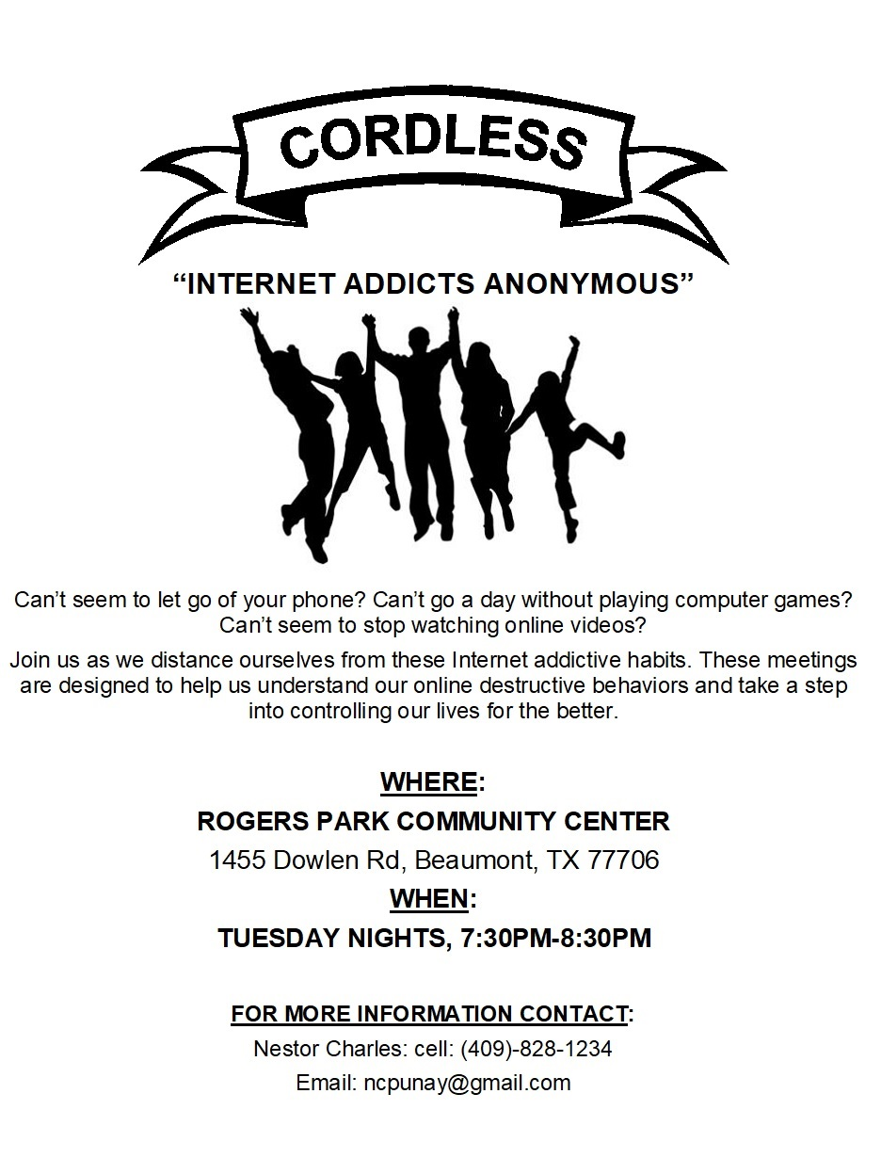
Flyer
In summation, having focused on various sections namely background, group logistics, group leadership as well as theory together with techniques and finally creating a flyer, it is clear that dealing with internet addiction and mostly peers is not an issue to be taken for granted. Various efforts are needed in curbing the situation before it spills to worse levels. For that reason, coming up with counseling groups and creating counseling session becomes necessary in addressing various issues that range from how one can combat internet addiction to how victims can interact in a group. Again, establishing the necessary group logistics and taking into consideration the group leadership, theories and techniques count towards having a successful counseling process as illustrated in the literature.

References
Brown, B. M. (2015). Psychoeducation group work. Counseling and Human Development, 29, 1-16.
Corey, G. (2015). Theory and Practice of Counseling and Psychotherapy, Volume 3. London: Engage Learning .
Gladding, S. T. (2016). Groups: A counseling specialty. (7th ed). Upper Saddle River, NJ: Pearson.
Glasser, W. (1985). Control Theory: a new explanation of how we control our lives. New York: Harper & Row.
Gazda, G. M. (2017). Group counseling: A developmental approach. Canadian Journal of Counselling and Psychotherapy, 3(4).
Kawabe, K., Horiuchi, F., Ochi, M., Oka, Y., & Ueno, S. (2016). Internet addiction: Prevalence and relation with mental states in adolescents. Psychiatry And Clinical Neurosciences, 70(9), 405-412. http://dx.doi.org/10.1111/pcn.12402
Jong-Un, K. (2014). The Effect of a R/T Group Counseling Program on The Internet Addiction Level and Self-Esteem of Internet Addiction University Students. International Journal Of Reality Therapy, 27(2), 4-12.
MacLennan, B. W., & Felsenfeld, N. (2019). Group counseling and psychotherapy with adolescents.
Mcclurg, L. (2017). Is 'Internet Addiction' Real?. NPR.org. retrieved from https://www.npr.org/sections/health-shots/2017/05/18/527799301/is-internet-addiction-real
Ostovar, S., Allahyar, N., Aminpoor, H., Moafian, F., Nor, M., & Griffiths, M. (2016). Internet Addiction and its Psychosocial Risks (Depression, Anxiety, Stress and Loneliness) among Iranian Adolescents and Young Adults: A Structural Equation Model in a Cross- Sectional Study. International Journal Of Mental Health And Addiction, 14(3), 257-267.
Stavropoulos, V., Kuss, D., Griffiths, M., & Motti-Stefanidi, F. (2015). A Longitudinal Study of Adolescent Internet Addiction. Journal Of Adolescent Research, 31(4), 442-473.
Wubbolding, R. E. (2017). Reality therapy. The Corsini Encyclopedia of Psychology, 1-3.
Young, K. (2017). Internet Addiction Disorder - Learn more about this new disorder. NetAddiction.
Young, K. (2014). Internet Addiction: The Emergence of a New Clinical Disorder. Cyberpsychology & Behavior, 1(3), 237-244.
Yu, T., & Chao, C. (2016). Internet Misconduct Impact Adolescent Mental Health in Taiwan: The Moderating Roles of Internet Addiction. International Journal Of Mental Health And Addiction, 14(6), 921-936.

